September Member of the Month
Caroline Paulson

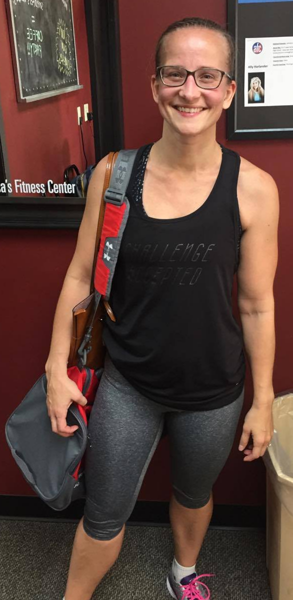
Caroline has been a member of AFC since 2016 along with her husband. Her kids Grant, Gabby, and Liam are often seen in the daycare room while Caroline goes to class. She loves all the different classes offered at the gym especially the 8:30am classes and the 4:30pm classes. Her motivation to keep coming to the gym comes from the instructors and their mutual passion for working out and a healthy lifestyle. Caroline likes that there are group classes offered and has made friends with many other members of the gym through these classes. When she isn’t at the gym, she likes exercising at home, going for walks, and playing with her kids. Thank you for your loyalty and membership over the past year and we appreciate your business!!

